Project Documentation Guidelines

1. Project Planning & Management
- Project Proposal: A mobile application named Auto Spare, built using Flutter, providing:
1. Online marketplace for car spare parts
2. Search, compare, and purchase functionality
3. Tow-truck request feature for car breakdowns
4. Revolutionizes how car owners find spare parts and handle emergencies.
5. Combines e-commerce with smart automotive support.
6. A future-ready platform for the spare parts market.
- Objective: Simplify spare parts shopping and enhance roadside assistance for car owners.
- Scope: Mobile app Android, Firebase backend, Firestore database, Google Maps integration.
- Project Plan:
Timeline & Milestones:
- Week 1-4: UI/UX design
- Week 5-6: Backend setup and database design
- Week 7-10: Feature development (search, cart, purchase)
- Week 10: Integration (maps, payment, notifications)
- Week 11-12: Testing and bug fixing
- Week 13: Final demo & deployment
Deliverables:
- UI screens
- Functional modules
- Technical documentation
- Final presentation & report
Resource Allocation:
- Project Manager & Mobile Developer: Ahmed Tharwat Ahmed - Overall project management & Flutter development
- Backend Developer: Ahmed Mostafa Almazon - Firebase backend & Firestore database
- Frontend Developer: Ziad Mohamed Rafat - Flutter UI development
- Documentation & QA: Salma Yousry Abdel Razek - Documentation, testing, QA
- Functional Mobile Developer: Omar Abdelalim Abdelfattah - Mobile feature implementation
- System Analyst & Data Support: Freddy Rafik Wahib - System analysis, data support
- Task Assignment & Roles:
- Project Manager & Mobile Developer: Ahmed Tharwat Ahmed - Overall project management & Flutter development
- Backend Developer: Ahmed Mostafa Almazon - Firebase backend & Firestore database
- Frontend Developer: Ziad Mohamed Rafat - Flutter UI development
- Documentation & QA: Salma Yousry Abdel Razek - Documentation, testing, QA
- Functional Mobile Developer: Omar Abdelalim Abdelfattah - Mobile feature implementation
- System Analyst & Data Support: Freddy Rafik Wahib - System analysis, data support
- Risk Assessment & Mitigation Plan.
- KPIs (Key Performance Indicators).

2. Lecturer Review
- Feedback & Evaluation – Lecturer’s assessment of the project.
- Suggested Improvements – Areas where the project can be enhanced.
- Final Grading Criteria – Breakdown of marks based on documentation, implementation, testing, and presentation.

3. Requirements Gathering

Stakeholder Analysis
- Car Owners: Quick spare parts access, price comparison, tow-truck assistance
- Sellers: Platform for listing products, inventory management, advertising
- Tow Truck Providers: Manage and respond to breakdown requests efficiently

Use Cases
- Search for spare parts
- Compare part prices
- View product details
- Add items to cart & checkout
- Request tow-truck assistance
- Seller uploads product listing

Functional Requirements
- User registration & login
- Spare part search with filters
- Add to cart & in-app purchase
- Tow-truck request with location detection
- Seller dashboard for product management
- Push notifications (order updates, confirmations)
- Google Maps API integration

Non-Functional Requirements
- Performance: Fast loading (<3 seconds)
- Security: Secure authentication, protected data
- Usability: Intuitive UI
- Reliability: High availability, error handling
- Scalability: Support growing user base
- Compatibility: Android & iOS
- Maintainability: Modular and documented code

4. System Analysis & Design

Problem Statement & Objectives
Problem: Difficulty finding correct spare parts, comparing prices, or requesting emergency support. Sellers lack a digital platform to reach customers efficiently.
Objectives:
- Easy search, comparison, and purchase of spare parts
- Emergency tow-truck service via GPS
- Seller-friendly platform
- Secure, scalable, cross-platform system

Use Case Diagram & Descriptions
- Actors:
- User
- Seller
- Purchaser
- Admin
- Main Use Cases: Search, Compare, Purchase, Request Tow Truck, List Products, Manage System

Database Design & Data Modeling
- Entities: Users, Sellers, Products, Orders, Tow Truck Requests, Advertisements
- Logical Schema:
- Users (UserID, Name, Phone, Email, Location)
- Products (ProductID, SellerID, Name, Price, Category, Image, Description)
- Orders (OrderID, UserID, ProductID, Quantity, TotalPrice, Date, Status)
- Tow Requests (RequestID, UserID, Location, Status, Timestamp)

- Data Flow & System Behavior

1. Seller creates account.
2.Admin accept/reject account.
3.Seller add product/s.
4.Admin accept/reject seller product/s.
5.User can buy the product/s.
6. (Optional) User can order Tow Truck.

- UI/UX Design & Prototyping

- Login
- Home Screen
- Category Screen
- Tow Truck Screen
- Cart Screen
- Profile Screen
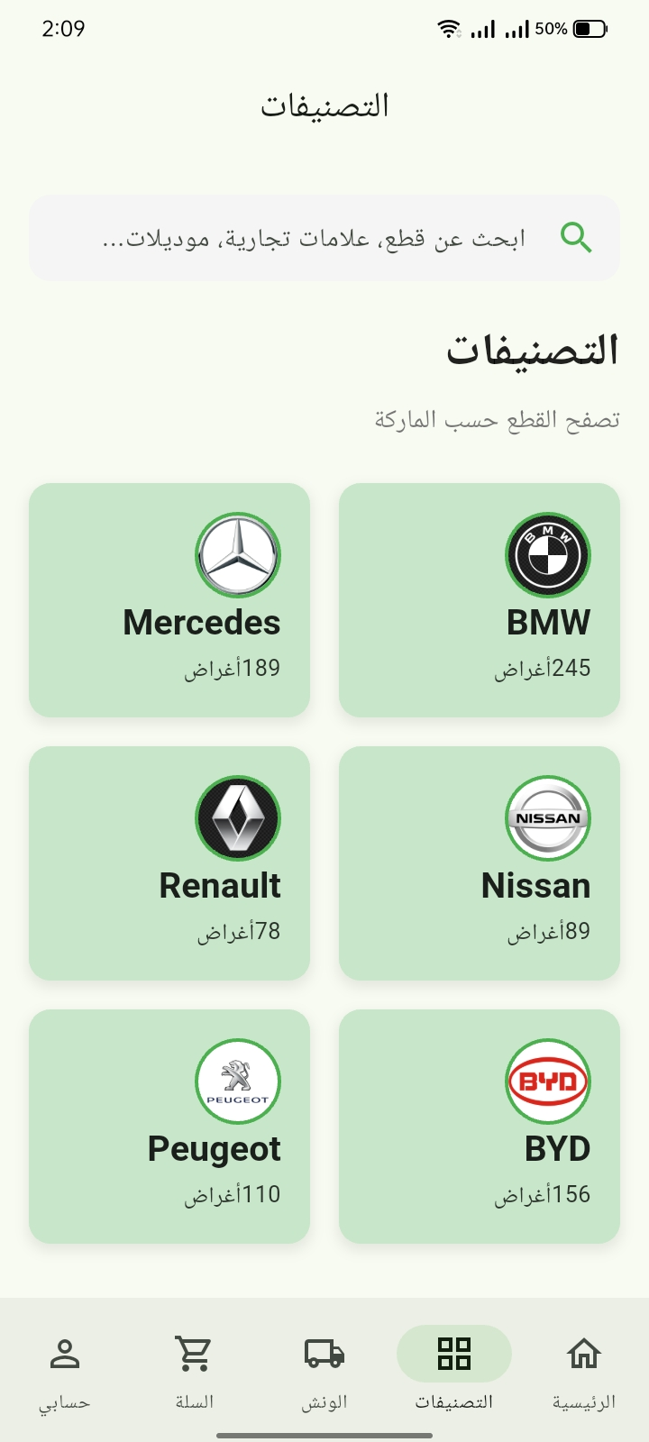
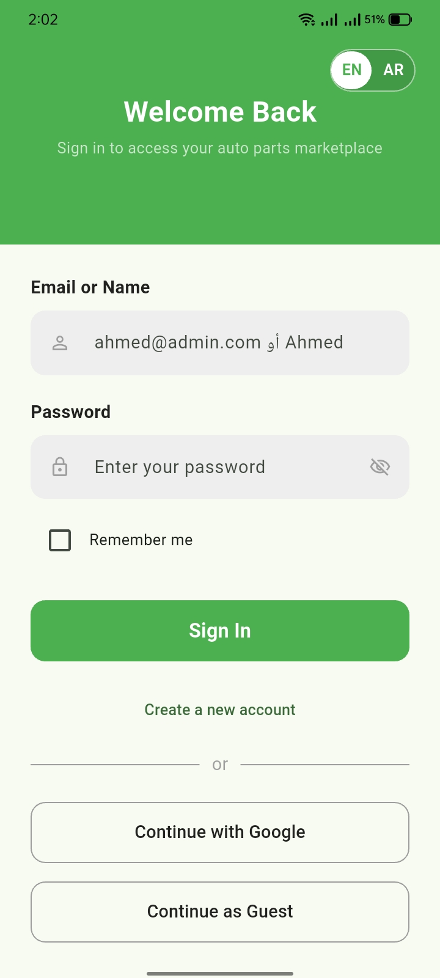

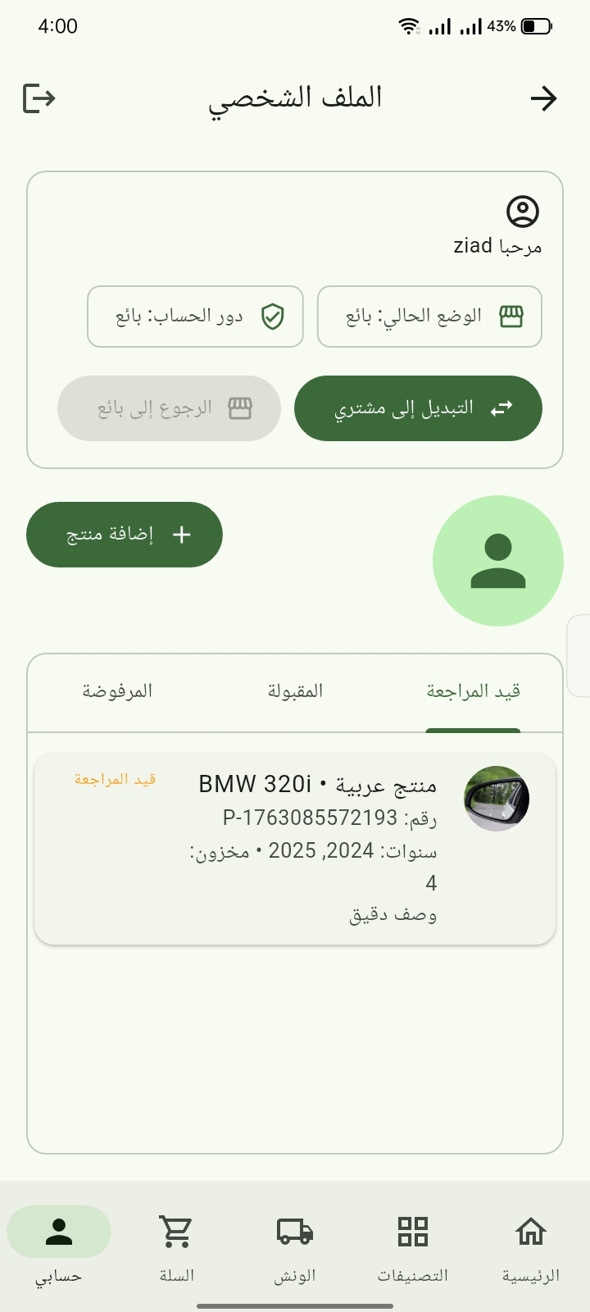
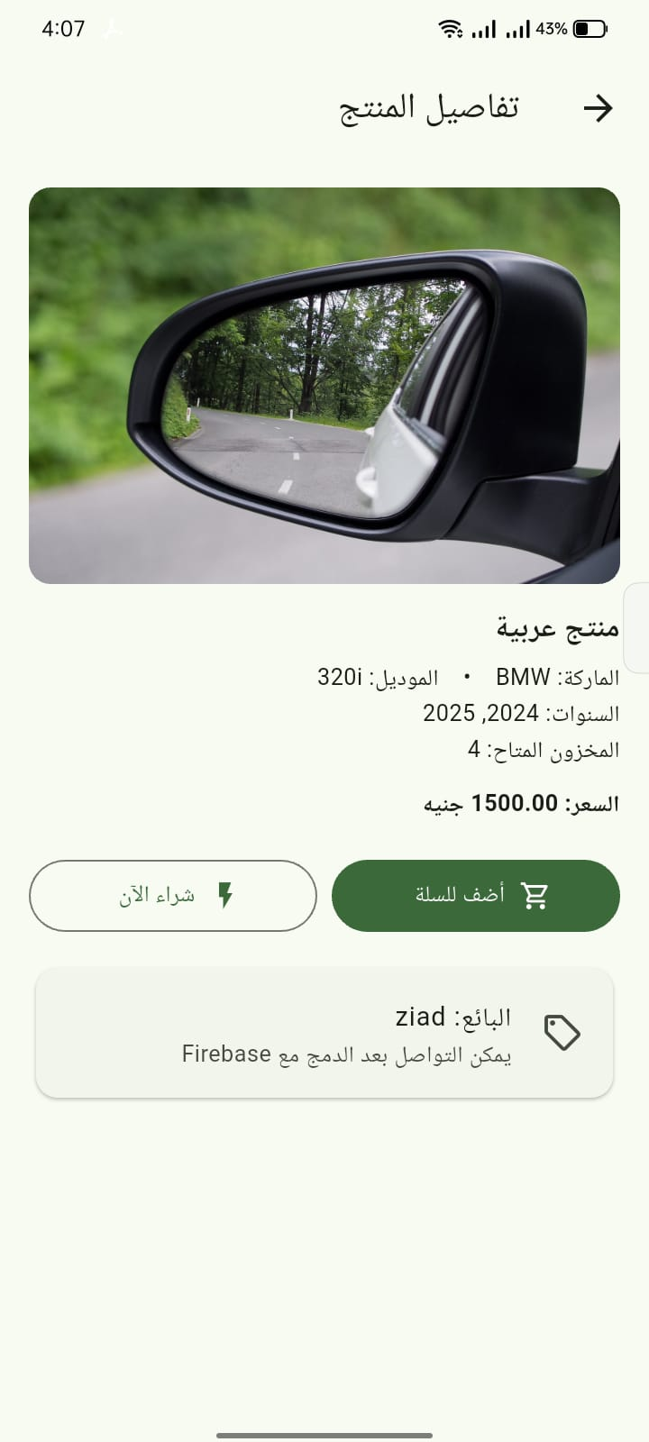

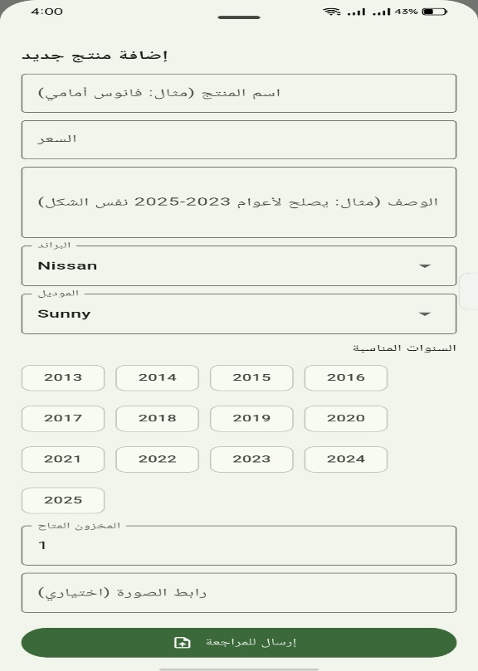
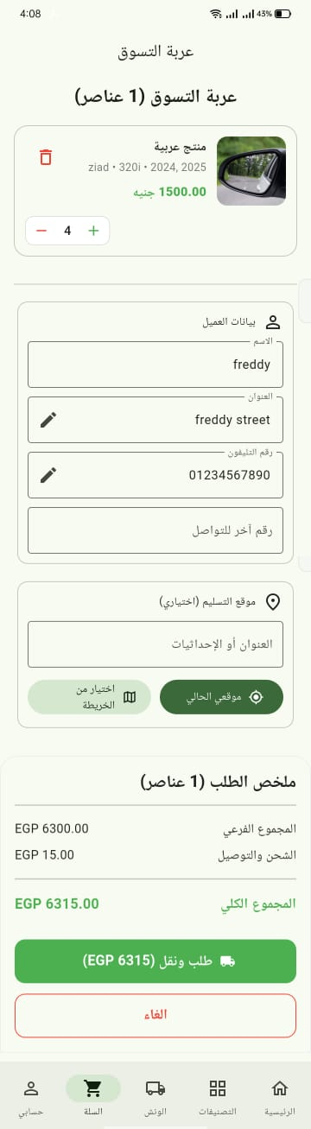

Ordering Product (user)

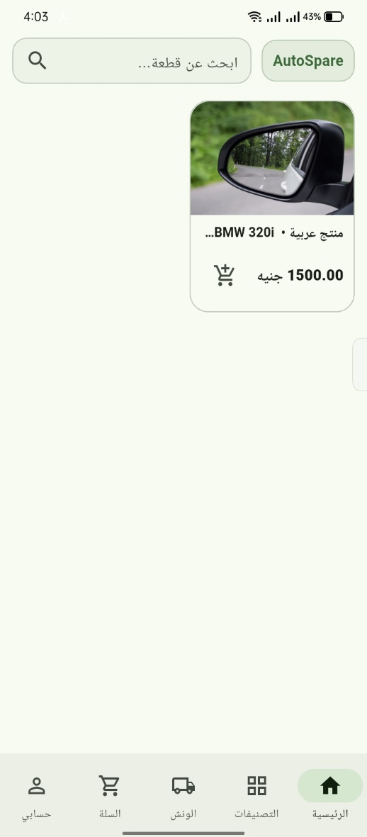
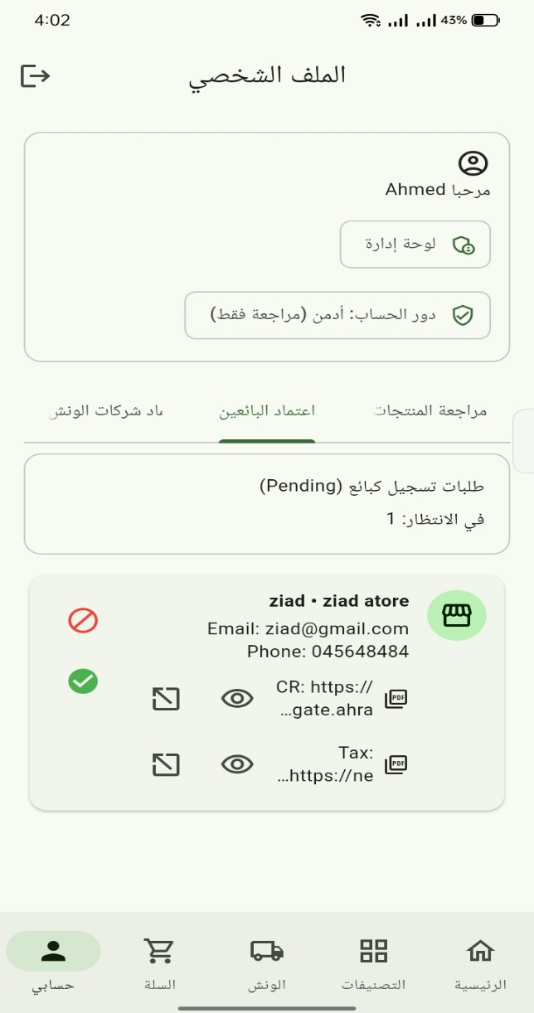
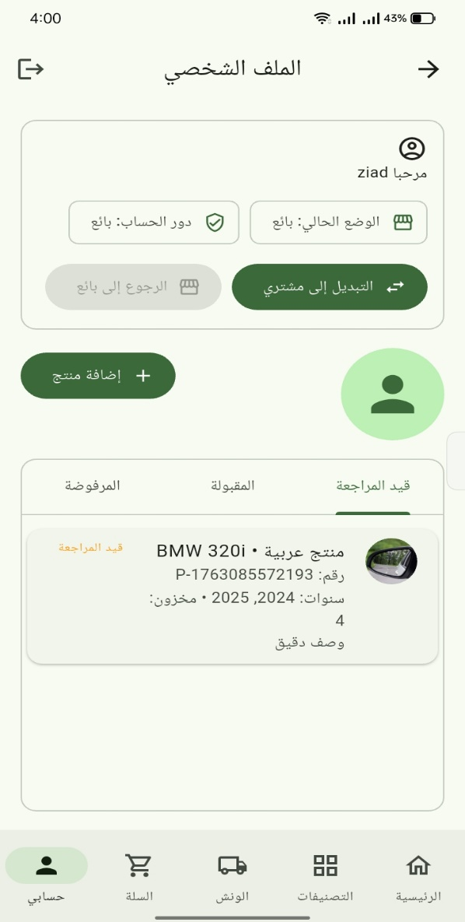

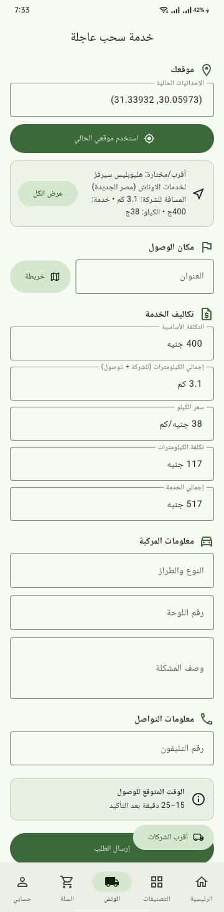
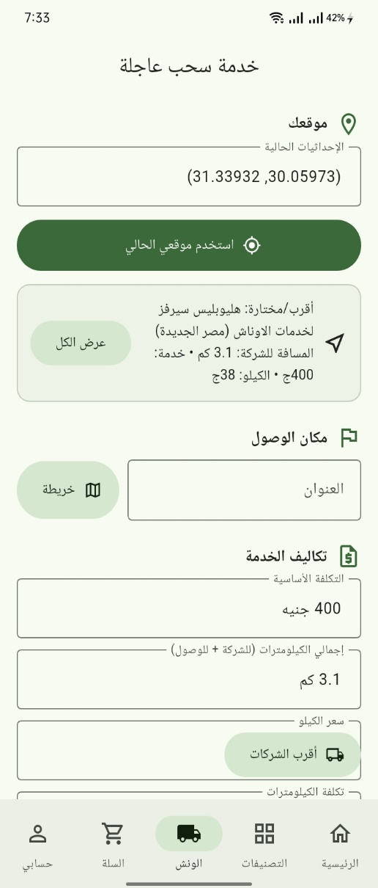
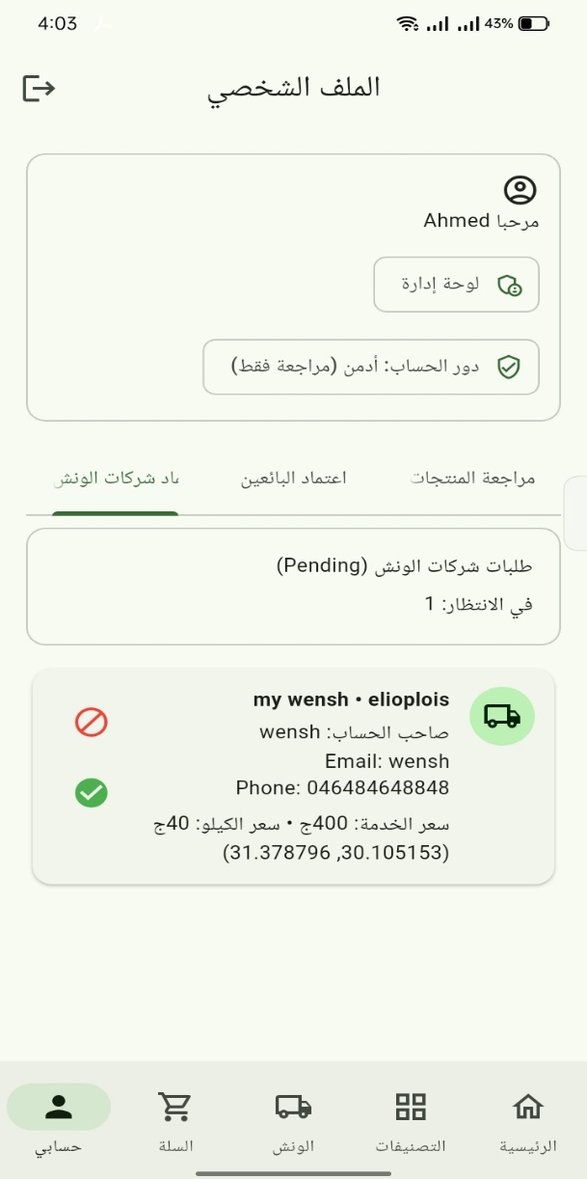

Tow Truck Request:

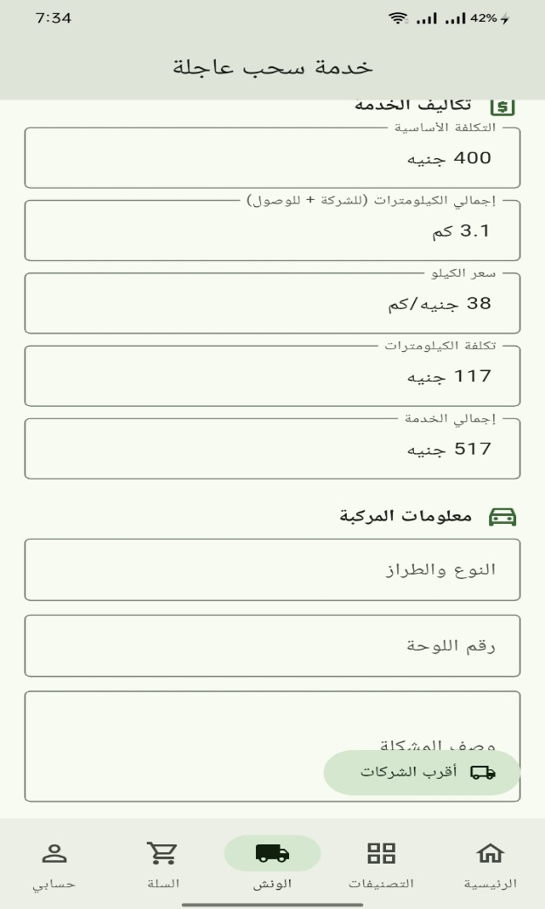
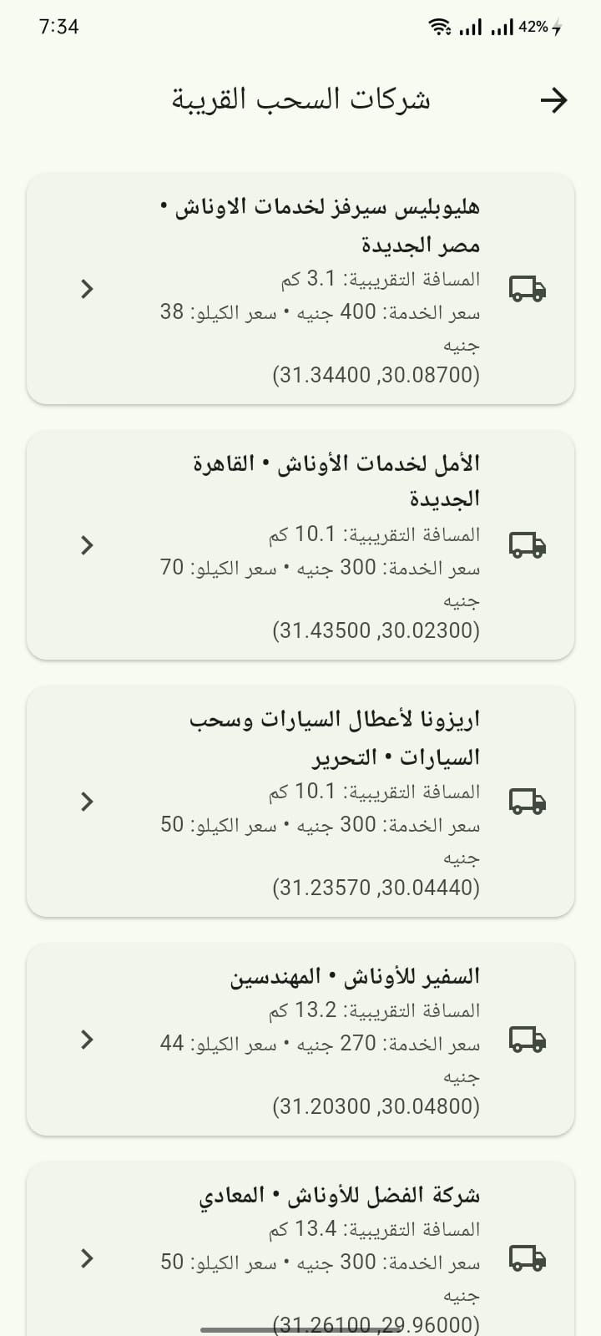
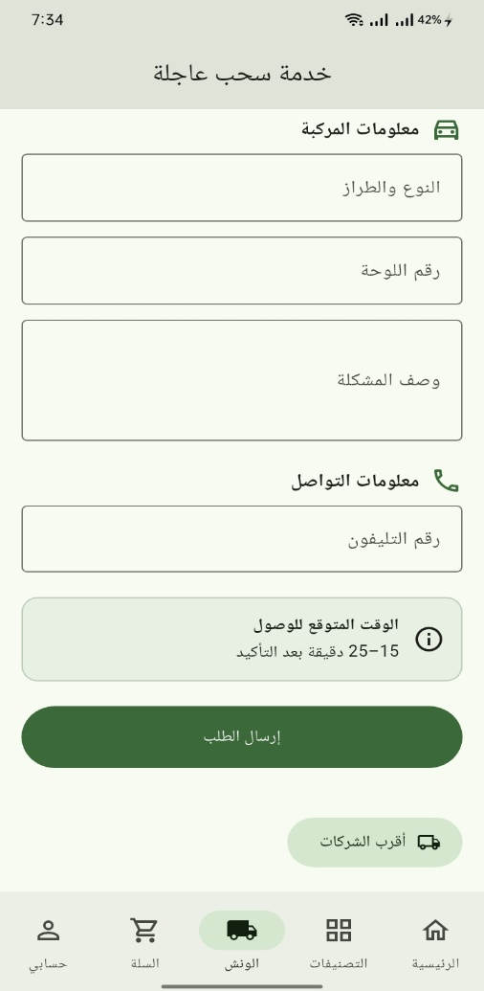

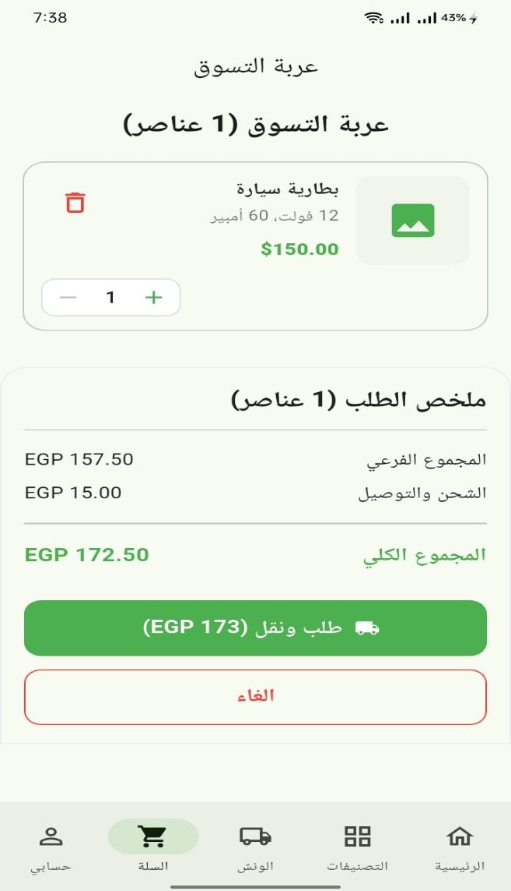
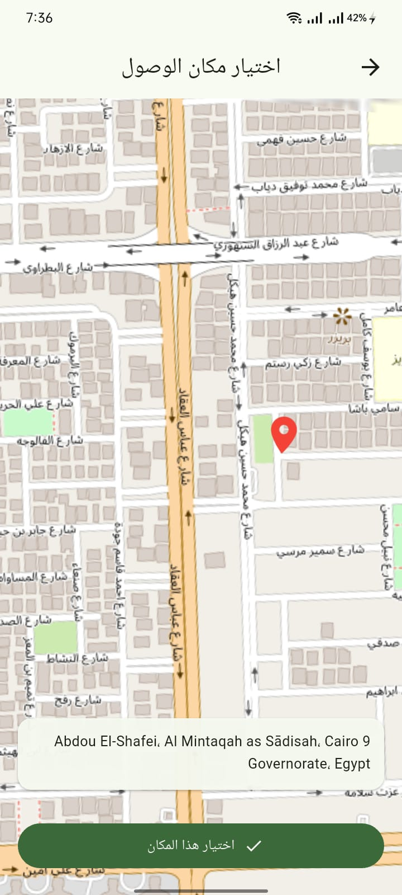

5. System Deployment & Integration

• Technology Stack: Flutter, Firebase, Firestore, Google Maps API, Stripe/PayPal.

• Deployment Diagram: Mobile app → Firebase backend → Firestore DB → Maps/Payment servers.

• Component Diagram: Authentication, Product Management, Cart & Payment, Tow Truck, Seller Dashboard.

6. Additional Deliverables (if applicable)

• API Documentation: Login/Signup, Product, Order, Tow Truck APIs (with Firebase rules), Maps & Location: Geolocation package (pub.dev).

• Testing & Validation: Unit testing, UI testing, Integration testing.

• Deployment Strategy: Publish APK, Play Store / App Store, Firebase hosting.

5. Implementation (Source Code & Execution)
1. Source Code

2. Version Control & Collaboration

• Version Control: https://github.com/AhmedAtaar/Team3_CAI3_SWD8_G1_AutoSpare.

3. Deployment & Execution
• README File – Includes:
• Installation steps
• System requirements (hardware/software dependencies)
• Configuration instructions
• Execution guide (running the project locally or accessing a deployed version)
• API documentation (if applicable)
• Executable Files & Deployment Link –
• Compiled software or packaged application (e.g., .exe, .jar, .apk).
• Deployed web/mobile app

6. Testing & Quality Assurance
- Test Cases & Test Plan – Document detailing test scenarios and expected outcomes.

7. Final Presentation & Reports
- Project Presentation (PPT)
- Video Demonstration

